**Linux Assignment 7**

1. What are branches in git

* In git there are two branches is there i.e., Main branch and develop branch
* Feature, hotfix and release are supporting branches

1. What is the use of branch

* Branch is used by add the files and store the data
* Default branch is main or master branch

1. You need to create 3 branches

Signup branch



Mobile number and password files

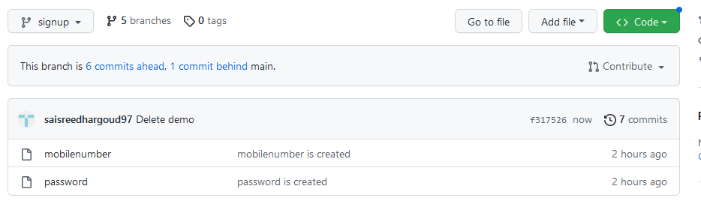

Login branch

Otp file and username file

Cart branch



Empty file and select items file

